The School Board of Broward County, Florida
District Advisory Council – Virtual TEAMS Meeting
DRAFT MINUTES
Wednesday, August 17, 2022 6:30 pm-8:30 pm
DAC Website: browarddistrictadvisory.ch2v.com/
Email: Districtadvisorycouncil@gmail.com

Chair – Chuck Harper Vice Chair – Malika Isaac
Recording Secretary – Brie-Anne Pendlebury Corresponding Secretary – Kathy Diaz
Communications Chair – Laurel Garfinkel

The chair, Chuck Harper, welcomed everyone to our first DAC meeting of the year. This meeting was held virtually via Teams. Meeting etiquette was reviewed: (Keep mics and phones on mute; Chat window should only be used for questions, Use the Raise Hand feature to speak) PLEASE COMPLETE THE ATTENDANCE FORM IN THE CHAT. One question per attendee per speaker, if there are still questions, they will be sent to the vice chair or recording secretary, forwarded to the appropriate presenter and replies will be presented at the next DAC meeting.

Meeting was called to order at 6:32 PM.

Approval of May Minutes: Held until September in person meeting.

Housekeeping
Attendance Requirements: We need to meet quorum every meeting in order to conduct business. If you miss 3 consecutive meetings or 4 in total, you cannot vote and must be reappointed.

Please fill out attendance form in the chat.

Sunshine Law and Ethics Training (10 minutes for returning members; 45 for new members) http://browardschools.com/Page/41329

Sign-up to receive emails on the DAC website http://browarddistrictadvisory.ch2v.com/

Presentation

Introduction of Advisory Officers and Chairs

District Advisory Council Chair: Chuck Harper districtadvisorycouncil@gmail.com
North Region Advisory Council Chair: Cynthia Dominique northareaadvisory@gmail.com
Central Region Advisory Council Chair: Dee Defoe caac.chair@gmail.com
South Region Advisory Council Chair: Carmelo Borges browardsoutharea@gmail.com

SAC and SAF
Bylaw adjustments for District and Region Advisories are to be reviewed and adjusted. These will be discussed at the September meeting where a subcommittee will be
Materials and trainings are available on the DAC and Region websites for SAF chairs. There is also a hard copy of the manual (binder) at their schools. Contact will be sent out on September 15th to compile a list of new SAC and SAF chairs by location.
BCPS Organizational Structure
The District underwent a revision in its structure. Some changes include the change from Areas to Regions (North, Central, and South) There is a superintendent for each of the Regions as well as an assistant superintendent that supervises non-traditional schools.
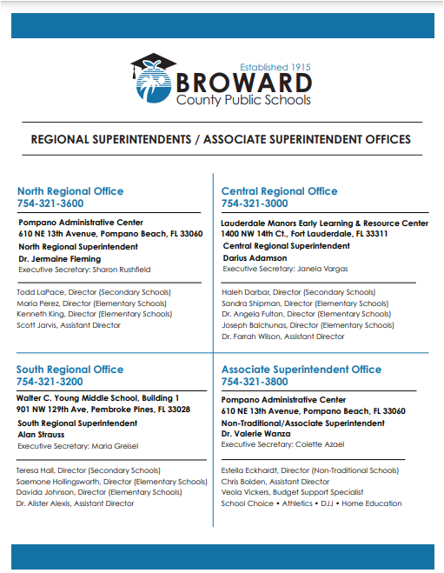

Policy Review Process: Mr. Andrae Hill
Many of the Broward Schools policies are in need of review. The goals of the policies are: assist with giving BCPS purpose and direction, creates tools that support teaching and learning, increases organizational effectiveness, and promote partnerships in creating holistic networks of support. It has been realized that over 20 policies that have not been amended, reviewed, or revised in over 5 years. Some have not been revised since the 1970s. These proposed actions include 19 policies discontinued, 66 policies are current but will be reformatted, 252 policies will have minor changes and reformatting, 12 policies will undergo major policies and be reformatted. This will be completed within 4 years before the next accreditation assessment. Moving forward policies will be reviewed every 5 years.
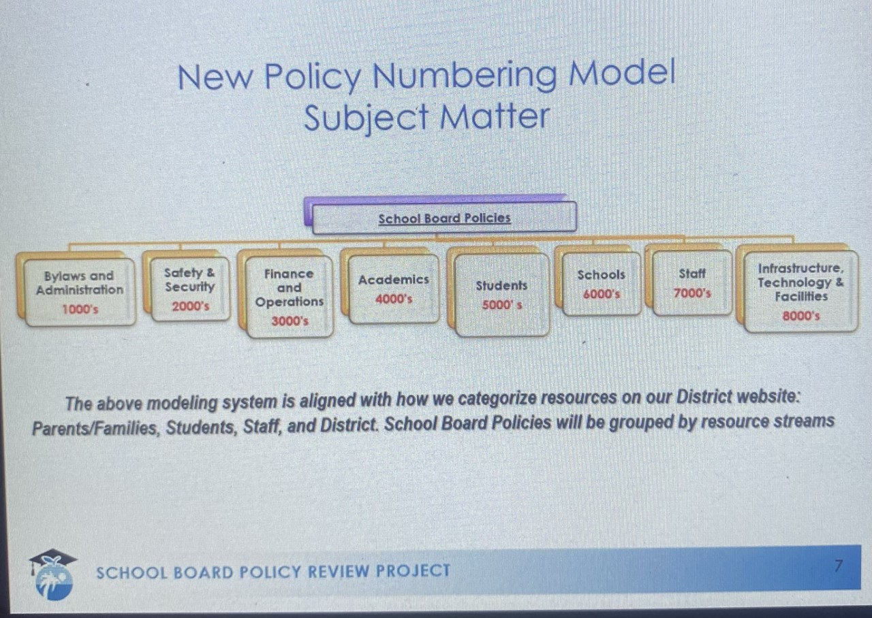
Policy reviews will include:
- Mandatory legal reviews for all policies
- Stakeholders: Community and committee input is still expected to be considered
- All reviews must still follow the Rule Development/Rulemaking policy
- All policies will now be placed in a standard template to ensure consistency

Human Resources: Judith M. Marte – Deputy Superintendent, Operations
Instructional: As of today, there are 270 teacher vacancies; 102 are classroom vacancies. They are all covered by a certified teacher (district staff). Many vacancies are high level math and sciences. There are less than 10 ESE teacher vacancies and 21 guidance vacancies.
Non-instructional Vacancies: 30 campus monitor vacancies but are all in the process of being filled. They have already been cleared and trained and are being paired with schools. Educational Support Vacancies: 95. Part-time food service vacancies: 83

Area Advisory Websites
District Advisory Council
http://browarddistrictadvisory.ch2v.com/content.asp?PageID=0
North Region Advisory Council
http://northareaadvisorycouncil.ch2v.com/
Central Region Advisory Council
http://centralareaadvisorycouncil.ch2v.com/
South Region Advisory Council
http://southareaadvisory1.ch2v.com/

Mark Your Calendars
- DAC Meeting September 14, 2022 6:30 pm @ KC Wright
- South Area - Informational, August 31, 2022 @ 9AM and 6PM on TEAMS
General Meeting: September 21, 2022, 9:00 AM @
McArthur High School
- Central Area - September 15, 2022 @9:45AM Indian Ridge Middle
- North Area - August 25, 2022 @6:30pm on TEAMS
General Meeting-Thursday, September 15th, 2022, 6:30-8:30pm, In-Person at Monarch High School
- ESE – September 21, 2022 @ 6:15pm at Plantation High School

DAC Website: BrowardDistrictadvisory.ch2v.com
Email: Districtadvisorycouncil@gmail.com

